Holiday PJ Story Time
December 4 (Tuesday)
6: 30 pm to appx. 7:30 pm

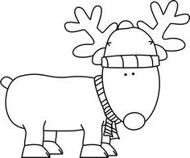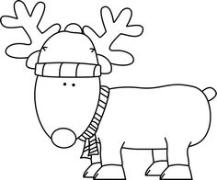

Come listen to Christmas stories and enjoy some light refreshments. All ages welcome.

FMI call the library at 926-4840.

